Overview: New User Interface

| December-20 |

**Document Overview**

**Documentation Goals**

This documentation is intended to provide an overview for Advantzware’s ***New User Interface****.*

**Documentation Disclaimers**

* Details the new program menu icons, and provides a reference to the deprecated icon versions.
* Provide an overview for the changes in the program’s general readability, using new color schemes and more accessible fonts.
* Provide an overview for the changes in the program’s usability, allowing the user to better utilize fuller screens, and detailing the better indication of currently selected items and columns.

**Table of Contents**

**Overview of Advantzware Icons** 2

General Program Icons 2

Specific Program Icons 3

Main Menu Icons 5

**New Feature: Screen Stretch and Maximization** 6

**New Feature: Color Scheme and Font** 7

Readability 7

Column Sorting and Data Highlights 9

# **Overview of Advantzware Icons**

Menu icons on each screen have been updated in order to look less cluttered, and more streamlined. Below, you can clearly see the distinction between the old and new icon menus.





If any icons are currently disabled on the selected menu, they will appear in a more muted grey color, indicating that they are currently unusable. Below, you can see a comparison between icons that are available or disabled.

|  |  |  |  |
| --- | --- | --- | --- |
| ***Enabled Icons*** | ***“Clicked” Indicator*** | ***Disabled Icons*** | ***Extra Information Indicator*** |
|  |  |  |  |

## General Program Icons

|  |  |  |  |
| --- | --- | --- | --- |
| ***Old Icon*** | ***New Icon*** | ***Icon Name*** | ***Icon Function*** |
|  |  | Change Move/Sort Column Mode | If this icon is in the “*Up and Down”* position, the user can click on column headers to sort data in ascending or descending order. |
|  |  | Change Move/Sort Column Mode | If this icon is in the “*Side to Side”* position, the user can click and drags on column headers to sort them in a different order than the default. |
|  |  | Export to Excel | Opens the *Export Excel* screen for the specific application you are currently using. |
|  |  | Import | Opens the *Importer Screen* with the current import type already populated. |
|  |  | Job Notes | Opens the *Machine (Operation) Notes* screen. These are specific job notes if the currently selected order has a job number defined. Please Note: A “*Checkmark”* indicates that there are notes present. |
|  |  | Add | Initiates the *Add New* functionality for the specific application you are currently using. |
|  |  | Attachments | Attachments for the currently selected object. Please Note: A “*Checkmark”* indicates that there are attachments present. |
|  |  | Print/List | Opens the *Print* screen for the specific application you are currently using. |
|  |  | Notes | Please Note: A “*Checkmark”* indicates that there are notes present. |
|  |  | Spec Notes | Notes for specific Finished Good items. Please Note: A “*Checkmark”* indicates that there are notes present. |
|  |  | Utility Application | Opens the *Utility Program Lookup* screen for the specific application you are currently using. |
|  |  | Help | Opens the *Help Information* screen for the specific application you are currently using. |
|  |  | UDF Viewer | Opens the *User Defined Fields Viewer* screen. |
|  |  | Conversions | Opens the *Fractions to Decimals Chart* by default. However, this can instead open a *“User Defined Image/Document”*, which can be defined using the ***“N” – “K” – “1”*** ‘*CalcBtnImage’*. |
|  |  | Exit | Exits the current screen. |

## Specific Program Icons

|  |  |  |  |  |
| --- | --- | --- | --- | --- |
| ***Old Icon*** | ***New Icon*** | ***Icon Name*** | ***Screen*** | ***Icon Function*** |
|  |  | Change Company/ Location | Main Menu | Allows the user to change their current company, location, or department. |
|  |  | View User Folder | Main Menu | Opens the *User Folder Task Results* screen. |
|  |  | Task Scheduler | Main Menu | Opens the *Dynamic Task Scheduler* screen. |
|  |  | User Settings | Main Menu | Opens the *User Settings* screen, which allows you to customize the Menu, Menu Size, and Language. |
|  |  | Import API | V-U-1 | Allows the user to import invoices using the EDI system. |
|  |  | Addresses | V-F-1  T-F-1 | Opens the *Address Information* screen. |
|  |  | Phone Info. | A-F-1/3  V-F-1  T-F-1  N-C-1 | Opens the *Phone Information* screen. |
|  |  | Misc. Fields | J-U-2  J-C  J-Q-1  T-F-3 | Opens the *User Defined Fields Viewer* screen, where the user can add or adjust their own defined fields. |
|  |  | Print Quote/ Invoice | E-Q  E-F/C  A-Q-1/2 | Opens the *Print Quotes* or the *Print* Invoice screen depending on which module is currently in use. |
|  |  | Capacity Page | E-F/C  J-U-1 | Opens the *Capacity Schedule Page Generation* screen for the currently selected estimate. |
|  |  | Transfer Job Data | E-F/C  J-Q-1 | Opens the *Transfer Job Data* screen for the currently selected estimate. |
|  |  | Customer Attachments | O-U-1  O-Q-1  V-Q-1  V-Q-2 | Attach files (such as Word/Excel/Images) for this specific customer order. Please Note: A “*Checkmark”* indicates that there are attachments present. |
|  |  | (ZoHo CRM | A-F-1 | Opens the *ZOHO CRM (Customers)* screen. |
|  |  | Employee Alert | A-F-1  G-F-1 | Opens the *Employee Alert Information* screen. |
|  |  | Load Tag  Creation | T-F-3  I-U-2/8 | Opens the *Load Tag Creation* screen. |
|  |  | Add | P-U-1 | Opens the *Best Buy Auto Create Board PO* screen. |
|  |  | Collection Notes | A-Q-1 | Opens the *Invoice Notes* screen. |
|  |  | Misc. Fields  Design Screen | N-S-8 | Opens the *User Defined Fields Builder* screen. |
|  |  | Security | N-S-8 | Opens the *Security Access by Menu* screen. |
|  |  | Set Fonts and Colors | N-S-8 | Opens the *Program Font and Color Settings* screen for the program that is currently highlighted in the Master List. |
|  |  | Menu Bar | N-S-8 | Opens the *User Menu Builder* screen. |

## Main Menu Icons

The new Main Menu Icons have been designed to look far less cluttered than in past versions. You will also notice that, instead of arrows indicating which screen system is open, there are ***“+”*** and ***“-“*** symbols. These symbols will indicate whether the menu selection has submenus, or simply opens an indicated program.

|  |  |
| --- | --- |
| ***Old Icons*** | ***New Icons*** |
|  |  |

# **New Feature: Screen Stretch and Maximization**

With the new updates to the User Interface, you can now maximize or stretch any screen, and the contents within that screen will stretch to fill the screen space. As shown in the example below, you will now be able to stretch the screen and see more data without having to scroll over quite as often.

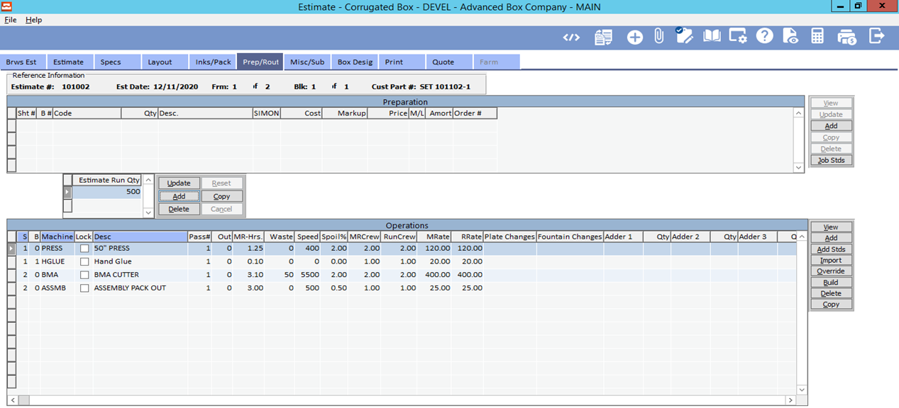

As you will notice, all of the buttons that are along the right side of the individual columns will stay in their proper place, but the columns themselves can extend for your viewing convenience.

Please Note: The system will save a user’s screen settings upon exit, and will remain the same the next time they open that screen. Screen size, column sorting, column widths, etc. are all saved user data.

For comparison, below is a screenshot of how the screen stretch used to work. As you can see, although the screen was maximized, the data within would stay the same size, thus creating a “bunched” set of information, and forcing the user to scroll through the data as though the screen were still set to use only half the space.

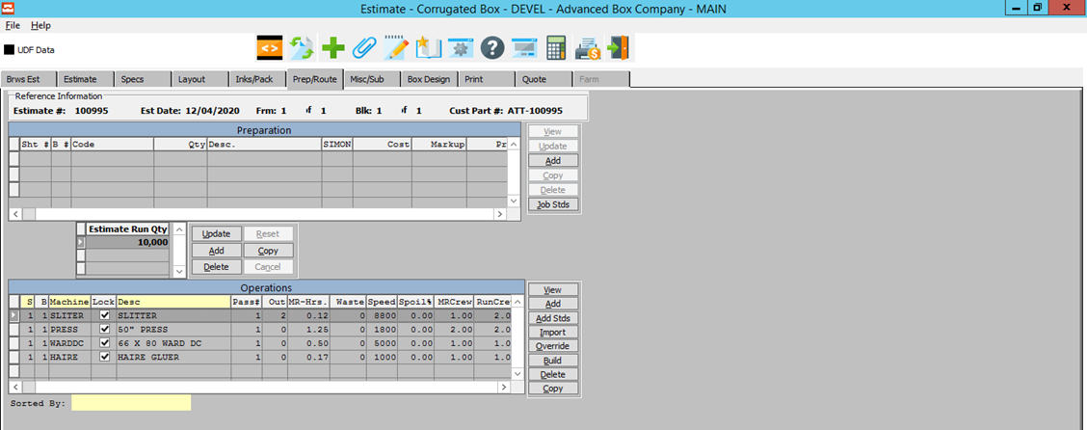

# **New Feature: Color Scheme and Font**

## Readability

The new color scheme is intended to look more like a document, or a sheet of paper. This is designed not only as an aesthetic upgrade, but also to make the screens easier to read.

You will notice, in the screenshot below, that the alternating rows are slightly different colors, which allows for better distinction between the data. The new font size and spacing is designed for easier reading, as the characters are no longer quite so close together.

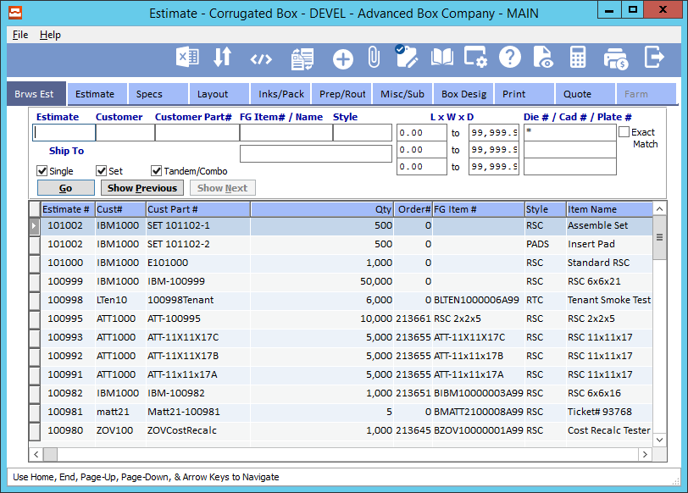

You will also find updates to column sizes throughout certain screens. Many of these columns have been extended, allowing for more data to be shown to the user such as longer Customer Names, Item Descriptions, etc.

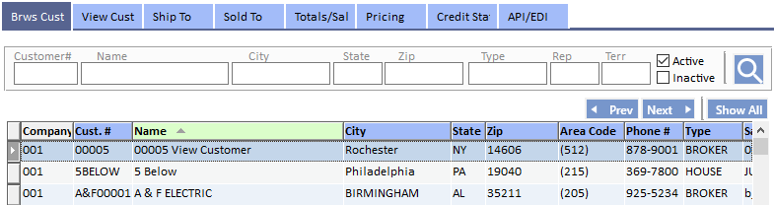

Below is a screenshot of the old interface. You will notice that the screen is much darker, and the font is much closer together than the updated version.

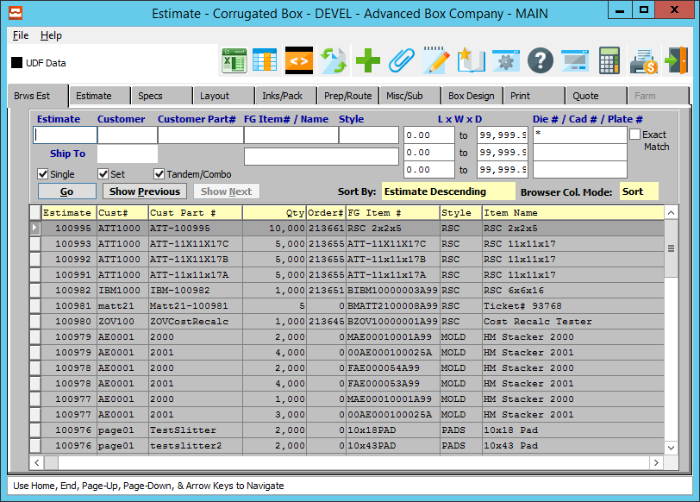

## Column Sorting and Data Highlights

There has also been an upgrade to way that selected rows and columns are highlighted. These indicators are now a much different color from the main color scheme in order to allow for quicker discernibility.

You will notice, in the screenshot below, that the column sort indicator is now a bright green, with a much more prominent arrow indicating the current the direction of the data sorting. Also, please notice that the highlighted row indicator is now much darker than the rows around it, providing a much clearer indication that it is currently selected.

Users will also be able to extend specific columns for easier review of longer data, such as Customer Names and Item descriptions.

Please Note: The system will save a user’s screen settings upon exit, and will remain the same the next time they open that screen. Screen size, column sorting, column widths, etc. are all saved user data.

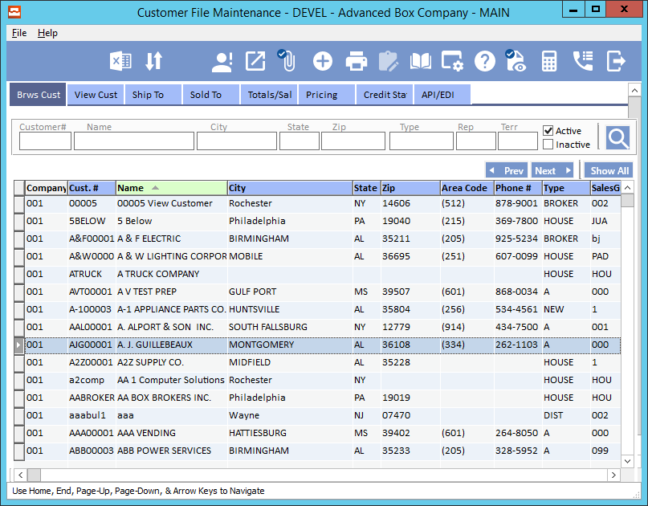

# **New zMessage 59: Keep Old Settings or Revert to Default Settings**

The new zMessage #59 is set to prompt a user for their preferences when entering a new screen.

If the user previously had selected columns organized according to their own preferences, this message allows them to keep their current settings, or to revert to the new default.

Afterwards, the system will save a user’s screen settings upon exit, and these settings will remain the same the next time they open that screen. Screen size, column sorting, column widths, etc. are all saved user data.

This new message is intended to allow users a chance to view the new User Interface system defaults, and begin their own customizations from a ‘clean slate’. If a user wishes to keep their previous settings, they have only to deny the changes using this zMessage, and their saved settings will remain.

As always, System Administrators have the option to set default answers for this message, and/or suppress the display. This can be done using the ***“N” – “Z” – “@”*** screen.

